DIFFERENTIATION USING THE CHAIN RULE
The following problems require the use of the chain rule. The chain rule is a rule for differentiating compositions of functions. In the following discussion and solutions the derivative of a function h(x) will be denoted by or h'(x) . Most problems are average. A few are somewhat challenging. The chain rule states formally that
.
However, we rarely use this formal approach when applying the chain rule to specific problems. Instead, we invoke an intuitive approach. For example, it is sometimes easier to think of the functions f and g as ``layers'' of a problem. Function f is the ``outer layer'' and function g is the ``inner layer.'' Thus, the chain rule tells us to first differentiate the outer layer, leaving the inner layer unchanged (the term f'( g(x) ) ) , then differentiate the inner layer (the term g'(x) ) . This process will become clearer as you do the problems. In most cases, final answers are given in the most simplified form.

  - PROBLEM 1 : Differentiate 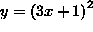.

  - PROBLEM 2 : Differentiate .

  - PROBLEM 3 : Differentiate 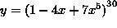.
  - PROBLEM 4 : Differentiate 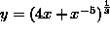.
  - PROBLEM 5 : Differentiate 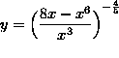.

SOLUTIONS TO DIFFFERENTIATION OF FUNCTIONS USING THE CHAIN RULE
SOLUTION 1 : Differentiate .
( The outer layer is ``the square'' and the inner layer is (3x+1) . Differentiate ``the square'' first, leaving (3x+1) unchanged. Then differentiate (3x+1). ) Thus,
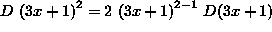
= 2 (3x+1) (3)
= 6 (3x+1) .
SOLUTION 2 : Differentiate .
( The outer layer is ``the square root'' and the inner layer is . Differentiate ``the square root'' first, leaving unchanged. Then differentiate . ) Thus,
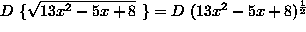
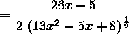
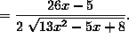
SOLUTION 3 : Differentiate .
( The outer layer is ``the 30th power'' and the inner layer is . Differentiate ``the 30th power'' first, leaving unchanged. Then differentiate . ) Thus,
SOLUTION 4 : Differentiate 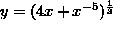.
( The outer layer is ``the one-third power'' and the inner layer is . Differentiate ``the one-third power'' first, leaving unchanged. Then differentiate . ) Thus,
(At this point, we will continue to simplify the expression, leaving the final answer with no negative exponents.)
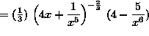
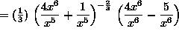
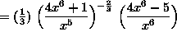
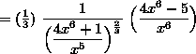
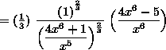
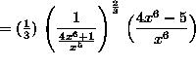
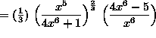
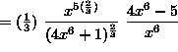
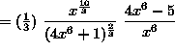
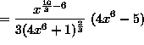
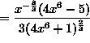
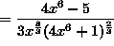.
SOLUTION 5 : Differentiate 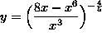.
( First, begin by simplifying the expression before we differentiate it. ) Thus,
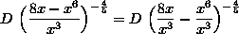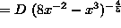
( The outer layer is ``the negative four-fifths power'' and the inner layer is . Differentiate ``the negative four-fifths power'' first, leaving unchanged. Then differentiate . )
(At this point, we will continue to simplify the expression, leaving the final answer with no negative exponents.)


